**Mockito Hands-On Exercises**

**Exercise 1: Mocking and Stubbing**

**Scenario:**

**You need to test a service that depends on an external API. Use Mockito to mock the external API and stub its methods.**

Steps:

1. Create a mock object for the external API. 2. Stub the methods to return predefined values. 3. Write a test case that uses the mock object.

**Source Code:**

**CalulatorRepo Interface:**

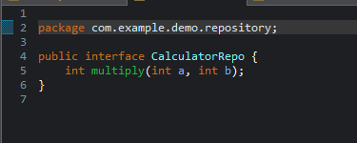

**CalculateService class:**

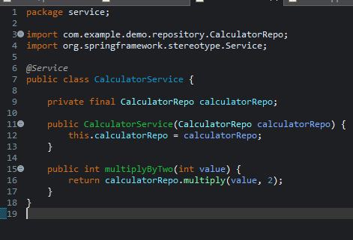

**Performing Mockito test:**

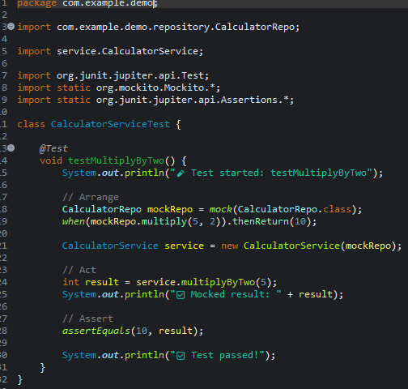

**Result:**

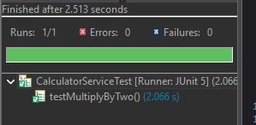

**Exercise 2: Verifying Interactions**

Scenario:

You need to ensure that a method is called with specific arguments.

Steps:

1. Create a mock object.

External Interface API:

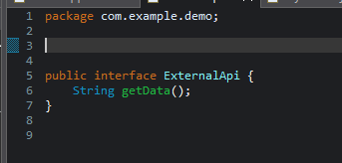

Service class:

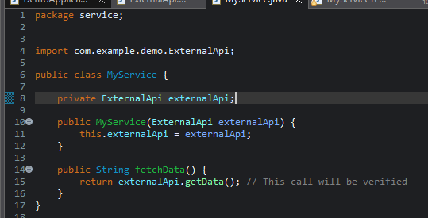

Mockito test:

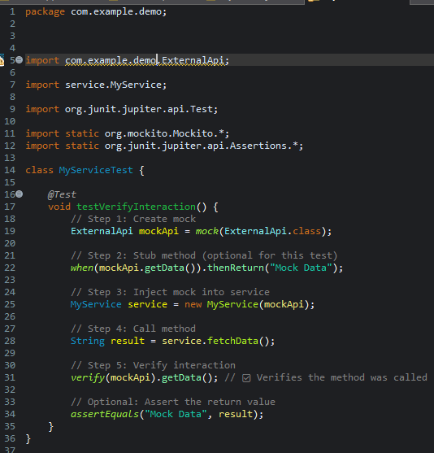

Result:

